Functional Requirement Specification

Version 1.3

**Vendor Order Portal**

|  |  |  |  |
| --- | --- | --- | --- |
|  | | | |
| AUTHOR | | | |
| Name | **Role** | **Date of Preparation/ Revision** | **Signature** |
| Manoj Kumar Sharma | Project Manager | 07-Jun-2015 |  |
|  |  |  |  |
| REVIEWER(S) | | | |
| Name | **Role** | **Date of Review** | **Signature** |
| Jennifer Sims |  | 16-Jun-2015 |  |
|  |  |  |  |
| APPROVER(S) | | | |
| Name | **Role** | **Date of Approval** | **Signature** |
| Ankur Sogani | GM | **Email Approval on 01-July-2015 for Version 1.0** |  |
|  |  |  |  |
| REVISION HISTORY | | | |
| Document Version Number | **Date of Release** | **Section/ Page # Changes** | **Details of Changes** |
| Version 1.1 | 31/03/2016 |  | Changes made as per discussion happened on 27th March,2016 with US & UK Business Teams. |
| Version 1.2 | 26/04/2016 |  | Added Roles Table and added the comments in Yellow for required sections |
| Version 1.3 | 27/04/2016 |  | Changes made so that Vendor and Buyer flow will be clearly visible for Portal |
|  | | | |

Table of Contents

1. Preface 4

2. Stakeholders 4

3. Purpose 4

4. Vendor Order Portal 5

4.1. Roles in the system 6

5. Vendor Order Portal – Vendor View 8

5.1. Vendor Registration 8

5.1.1. Sign Up process 9

5.1.1. Portal Action after Vendor Registration 11

5.2. Vendor Approval Process 12

5.2.1. Vendor Login Details 13

5.2.1.1. Login Details screen Acceptance Criteria 13

5.3. Vendor View -Home Page 13

Home Page screen details 13

5.3.1. My Account (in edit mode) 14

5.3.2. Accounts Details screen Acceptance criteria 14

5.4. QC Guidelines 15

5.5. Place Offer 15

5.5.1. Upload Offer – External Vendors 15

5.5.2. Upload Offer – Internal Vendors 16

5.5.3. Search Offer – Vendor View 17

5.5.4. Offer workflow (Action Taken on Offer) 18

5.6. Shipment Entry Screen 19

5.7. View Shipment Details entry 20

6. Vendor Order Portal – Buyer View 20

6.1. Buyer Registration 20

6.2. Buyer Login Details 21

6.2.1.1. Login Details screen Acceptance Criteria 22

6.3. Buyer View -Home Page 22

Home Page screen details 22

6.3.1. My Account (Buyer View) 23

6.3.2. Accounts Details screen Acceptance criteria 23

6.4. QC Guidelines 23

6.5. Place Offer 24

6.5.1. Search Offer – Buyer View 24

6.5.2. Offer workflow (Action Taken on Offer) 24

6.5.3. Offer View Mode 25

6.6. Place Order- External Vendors 26

6.7. Shipment Tracking Report 27

6.8. Vendor Payment Status-PO Wise 27

6.9. QA Sample Evaluation Report 28

7. Super Admin Screens 28

8. Assumptions 29

# Preface

The Notes, Important Sections, and warnings are represented using the following symbols:

|  |  |
| --- | --- |
| **SIGN** | **DESCRIPTION** |
| D:\Template\images\1.jpg | A **Note**contains helpful suggestions or references to material not contained in the document. |
|  |  |
| D:\Template\images\2.jpg | An **Important Section** contains information essential to successfully completing a task or learning a concept. |
|  |  |
| D:\Template\images\3.jpg | A **Warning**contains information or instructions, which, if not heeded, can result in a security risk, irreversible loss of data, or significant cost in time or revenue or both. |

# Stakeholders

This requirement is originally gathered for LC Buyers, keeping in mind Ankur Sogani as key stakeholder. Later on after discussion with UK Buyers (Amit/Zahid/Deepak), their requirements were also added.

# Purpose

The main purpose of this project is to have better communication with the LC Vendors & TJC Vendors and remove the endless email communication and follow ups

**Approved vendors can come up and share their design information over the portal by login to the portal.**

D:\Template\images\1.jpg This requirement was collected by discussing with LC team, by studying other vendor portals like QVC & Helby Imports.

# Vendor Order Portal



## Roles in the system

|  |  |  |  |  |
| --- | --- | --- | --- | --- |
| **Role Name** | **Vendor Approval** | **Offer Approval** | **Registration Email** | **Remarks** |
| Chairperson | Yes | No | Will receive Vendor registration email, that a vendor is registered |  |
| GMM (General Merchandize Manager) | Yes | Yes ( Second level approval for External Vendors) | Will receive Vendor registration email, that a vendor is registered | GMM should be able to add his remarks for the Vendor Approval. Able to manage Vendors for his Product Category. |
| Buyer Assistant | Able to see Vendor Registration form details | No | Will receive Vendor registration email, that a vendor is registered. | Able to see the Offers related to his/her category, so that he can work as Buyer assistant. |
| Buyer | Able to see Vendor Registration form details | Yes |  | Able to see offers, Will receive Offer upload email, Shipment tracking email once Vendor enters shipment details. Able to manage vendors for his product category. |
| Vendor |  |  |  | Vendor can register for channel and category. Can edit his registration details, Vendor will receive the Login credentials after registration approval, able to upload new offer, Edit existing offer, Enter shipment details, edit shipment details, receive emails for Offer approval, email for Shipment received acknowledgement by Buyer |
| BPO User |  |  | Shall receive an email on approval of specific offers.  Chandra wrote: 26/04/2016 | Able to download the Final approved offer, so that they can create PO in JV3. So it means they will be able to see the required offers for the respective channel. |
| VGL Super Admin |  |  |  | Able to manage the application, Able to create vendors (internal), Able to assign the both Channels rights to Vendor (external), Able to create Buyer, Able to create Product Categories |

Rakesh wrote: Can we keep one more Role - Vendor Assistant . like Buyer Assistant. This will be required in case of VGL & STS China both , where we have different team members to take care of different channels.  This can be achieved by creating multiple vendors like VGL-LC; VGL-TJC; ……….  In this case the above scenario of One vendor association with multiple channels will not come.  Manoj – Please discuss it further

# Vendor Order Portal – Vendor View

## Vendor Registration

1. Vendor can come to the login URL and can click on the Sign Up link, if he is not already registered.

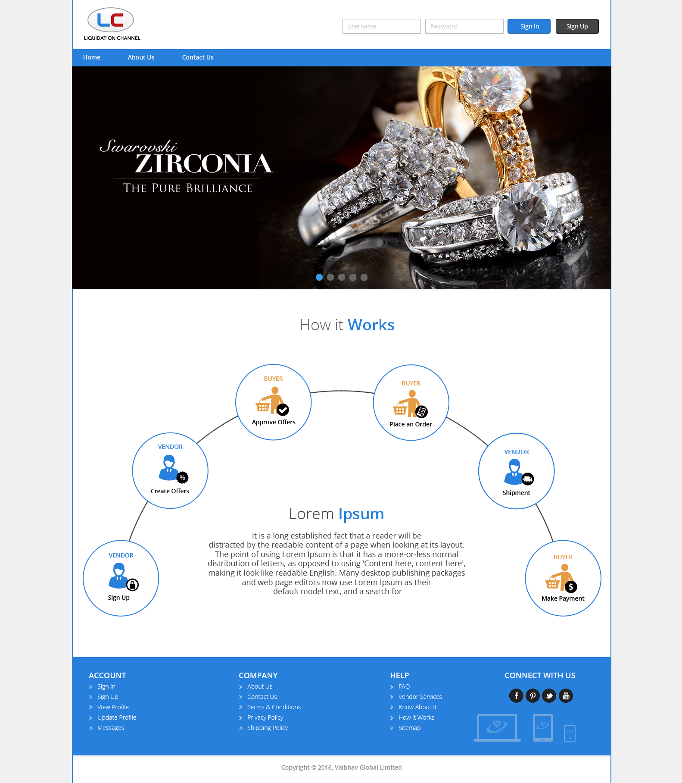

2. If Vendor already has the username and password, he will be able to Sign In by entering correct username and password.

### Sign Up process

Step1: Vendor clicks on Sign Up link then system will first ask for **PRODUCT CATEGORY** ( Jewelry OR Lifestyle).

D:\Template\images\1.jpg We will not ask for the selection of Channel at the of Registration because we suppose that Vendor will be redirected from the portal and Channel details will be picked from the Locale specific settings.

Step 2: On the same screen of Category selection we will have Company Information form available for download. So that Vendor can download the form, fill it and scanned it for upload over the portal.



As per discussion with Reeta Sharma on 27/04/2016:-

Every vendor should sign the Company information form- US Patriotic act and then he can scan and upload over the portal.

Kotes: Can we store the SSN no. in complete in the sytem??

1. As per the Buyer assistant, every Vendor fills the required information in the form, to use it in the JV3 Party master. Every vendor sign the document always.
2. As already discussed with Finance team, there is not much use of the Company information form, other than the creation of JV3 Party master and storing Vendor Address & Contact details.
3. Even if some Vendor do not fill some information, then Buyer assistant is calling them to get the required information.
4. So there should be possibility in the system where Buyer assistant can go and upload the updated Company information document. (If we are going by the concept of attaching the scanned document during registration.)
5. Related to SSN query, there are two type of Vendors;
   1. Some are filling Federal Tax Identification Number in case of company and other Vendor which are individual, they fill the SSN. So people who are filling SSN fill the SSN number in complete, without hiding the digits.
6. As this Company information Buyer assistant will send to Chairperson, GMM, Payroll & Accounts department with limited set of people. So chance of leakage of confidential information will be minimal.

D:\Template\images\1.jpgAll information in the US Registration form is mandatory, as discussed with US Finance team and Merchandising Team.

D:\Template\images\3.jpgNeed to take the Registration form for UK location.

Step 3:-

Once Vendor selects Product category, ready with filled & scanned Company information form. He will see the below screen for adding the bare minimum company information. This info we will use in our software or we can use it for creating JV3 Party Master manually.

He will upload the scanned company information form. Uploading of scanned Company information form is mandatory.

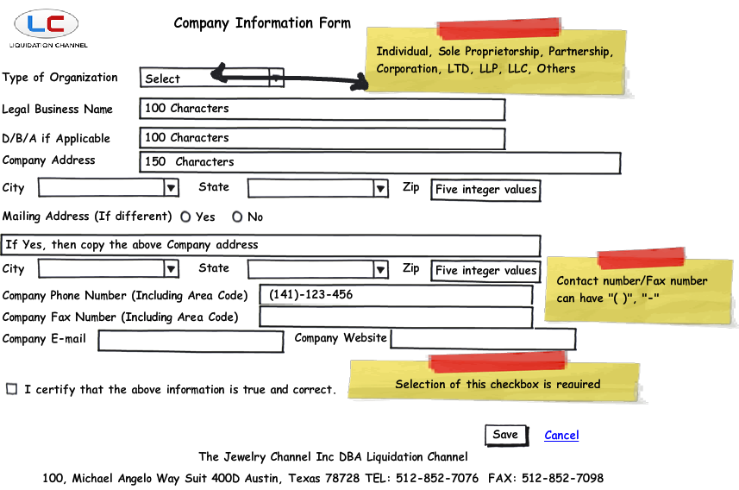

Step 4:-

4. Vendor will be able to upload one document also, along with the Registration form. This Document he will be able to upload, after uploading the scanned Registration form and before doing form submit. Uploading a document is optional. Max size (10 Mb).

5. Once Vendor uploaded the Registration form and uploaded the document, he will click on the submit button. After successful submit, system will trigger a Welcome email to Vendor email id which he provided at the time of Registration. This email id will be company email id, in case of US Registration form.



### Portal Action after Vendor Registration

1. On successful Registration form submit, system will trigger a Welcome email to Vendor. This email is an assurance from LC/TJC side, that you registered on our portal and we will get back to you after reviewing your registration. “Thanks for registering on the Vendor Order Portal, we will get back to you shortly". (This is a dummy text)
2. Also Portal will send emails to Chairperson, GMM (General Merchandize Manager) & Buyer Assistant.

D:\Template\images\1.jpgBuyer assistant should be able to take the Registration form printout, for her reference, same is applicable for Chairman & GMM.

## Vendor Approval Process

1. If a Vendor at the time of Registration Vendor selects the Product category as “Jewelry” then the vendor signup email should trigger to Chairperson, GMM (Jewelry) & Buyer assistant.

**Case 1**: Vendor Selected Channel as “Liquidation Channel, USA” & Product Category as “Jewelry” then email will trigger to Chairperson, GMM (Ankur Sogani) & Buyer Assistant (Jennifer Sims).

**Case 2**: Vendor Selected Channel as “The Jewelry Channel Limited, UK” & Product Category as “Jewelry” then email will trigger to Chairperson, GMM (Amit Agarwal) & Buyer Assistant (…..).

**Case 3**: Vendor Selected Channel as “Liquidation Channel, USA” & Product Category as “Lifestyle” then email will trigger to Chairperson, GMM (Deepak Sharma) & Buyer Assistant (Jennifer Sims).

**Case 4**: Vendor Selected Channel as “The Jewelry Channel Limited, UK” & Product Category as “Lifestyle” then email will trigger to Chairperson, GMM (Amit Agarwal) & Buyer Assistant (…..).

1. Vendor approval rights are with Chairperson & General Merchandize Manager (GMM).

D:\Template\images\1.jpgOnce Vendor provides the Vendor details on the Registration form. Channels need to approve the Vendor or ask for more information. If there is anything more information, they Buyer can contact over the phone/email.

1. Once the Vendor is approved, he will get his login details over the email. Chairperson, GMM & Buyer assistant will also receive an email from the portal, that the Vendor has been approved in the system.

Need to discuss with Q3, how they will manage multiple logins for one vendor. Because Internal as well as external vendors could have multiple users.

1. Vendor approval process will be of 2 step;
2. GMM should be able to put his feedback for the Vendor in the Offer Remarks section. These remarks should not be visible to External Vendor.
3. Chairperson should be able to see GMM feedback and should be able to approve the Vendor.
4. If Chairperson gives his feedback over the email, then GMM should also be able to click on the Approval button. So that there should not be any delay in the Vendor approval.

### Vendor Login Details

1. User name & Password will be generated, once the Vendor is approved. Login credentials will be shared to the Vendor over the email.

#### Login Details screen Acceptance Criteria

1. Password requirements will be same like Common Portal for Gemstones project.
2. Forgot Password link will open a new window, where user will enter his email id and a temporary password change link will be sent to his email id.
3. There should be maximum login attempts defined in the system, to avoid misuse of the Username/Password.
4. If user enters the Username and clicks on the login button, then system should give message that "Please enter the password".
5. If user enters correct username and wrong password then system should show a message "Please enter correct password" or Click on Forgot Password Link”

## Vendor View -Home Page

Once Vendor will login he will see the home page like below;

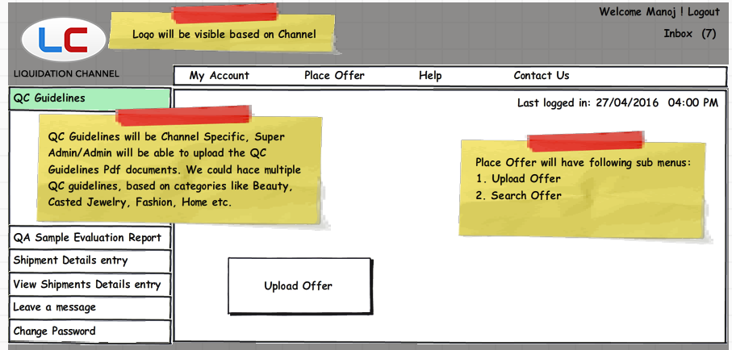

### Home Page screen details

1. My account: This will allow the vendor to change his Profile details. For more details see the My Accounts section- Vendor view in detail.
2. Upload Offer will allow the vendor to upload the designs / product details, so that he can communicate with the Channel Buyers.
3. Shipment details entry screen: On this screen Vendor will enter the shipment details, airway bill no. and will be able to upload the file in the system. For this a Shipment entry screen will be designed in system and will be filled by Vendor. For every successful shipment entry done, an email will trigger to buyers/Warehouse team.
4. Vendor will be able to see the already entered Shipment details entered for earlier shipments.
5. QA Sample Evaluation report will be visible to Vendor / Buyers. Vendor / Buyer will be able to see the QA report SKU wise. Buyer or Buyer assistant will be able to upload the QA Sample Evaluation report.
6. Place Order: Once Offer is approved, then user will be able to create Purchase Order based on the approved offer.
7. Logo in the header should be visible based on the Channel Specific.
8. The home page will have Left panel, header portion, Centre display area, Menu bar, logo etc.
9. Vendor will be able to Change Password from Change password screen.
10. Leave a message: It will be a chat box where Vendor will be able to leave a message for the Buyer or would be able to see the message left by Buyer for Vendor.

### My Account (in edit mode)

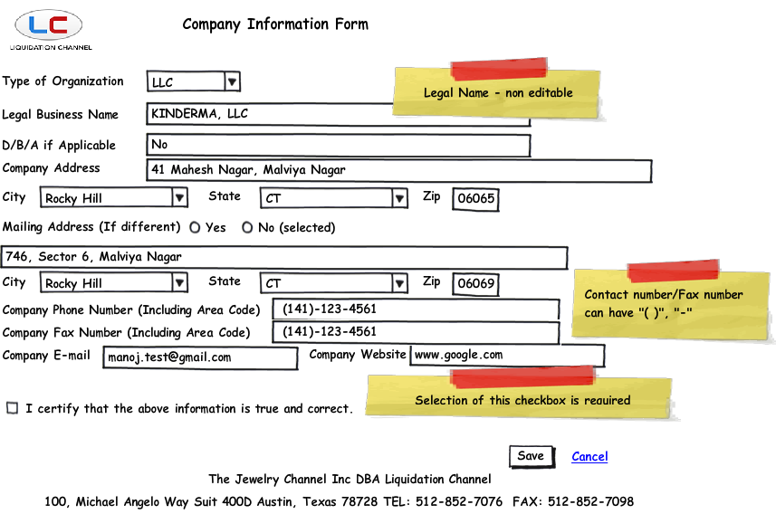

### Accounts Details screen Acceptance criteria

* Last update date of “My Account” screen should be available in the right most side of the screen when My account detail screen is in View mode.
* For every change in the Account details, an email should be triggered to the Accounts team for specific Channel.
* Legal Business name should be non-editable. It should be editable based on vendor request and should be done by Admin only.
* On save task system should give a message to the user that "Your details are saved successfully."
* Cancel should ask for the confirmation whether user want to move away from the page.
* Once the details are saved, My account details should be visible in "View" mode. View mode of the screen should show the "Update Account details" hyperlink on it.

## QC Guidelines

QC Guidelines will give information about the QC guideline/requirements for Apparel, Jewelry, Beauty, Home Textile, Home decor etc. This will be defined by Buyer and should be followed by Vendors for the delivery. Super admin/Admin user should be able to upload the QC guidelines on the portal. These guidelines will be channel specific.

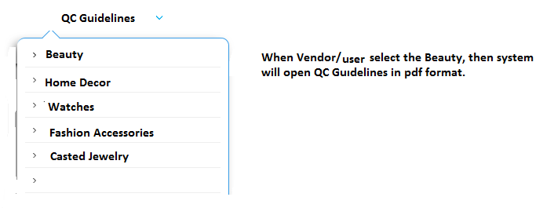

## Place Offer

### Upload Offer – External Vendors

When vendor clicks on the Upload offer, then vendor will be able to see the below screen.

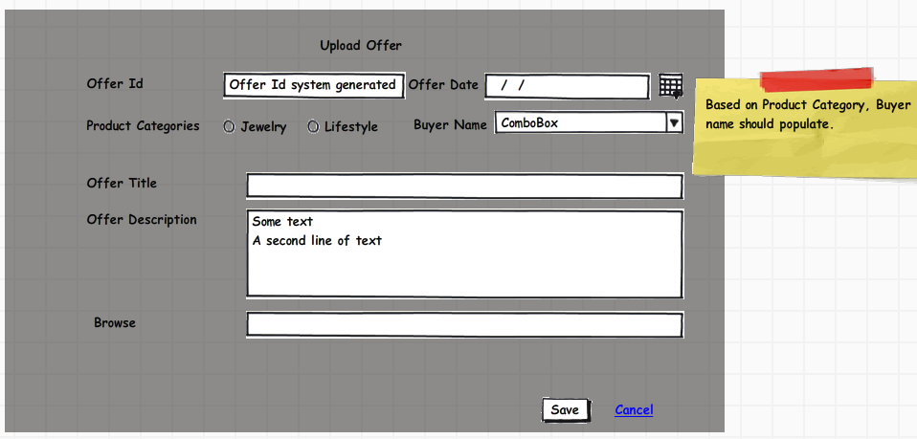

1. Offer Id will be system generated. For every new offer uploaded, an Offer Id will be created.
2. An email will be triggered to respective buyer, so that Buyer will be able to know that an offer is uploaded by Vendor.
3. Based on product category selection, Buyer name drop down should be loaded with Buyer name values.
4. User should be able to upload the document on the Offer creation screen.
5. This offer with the uploaded excel will be visible to Buyer.
6. Based on the Product category and Buyer selected, email will trigger to the respective Buyer along with the respective GMM. (Updated on 26/04/2016)

### Upload Offer – Internal Vendors

Internal vendors are VGL Group Vendors like Vaibhav Global Limited, ([STS Gems Limited, China](http://www.vaibhavglobal.com/contact)), ([STS Gems, Thailand](http://www.vaibhavglobal.com/contact)), [STS Gems, Bali](http://www.vaibhavglobal.com/contact)

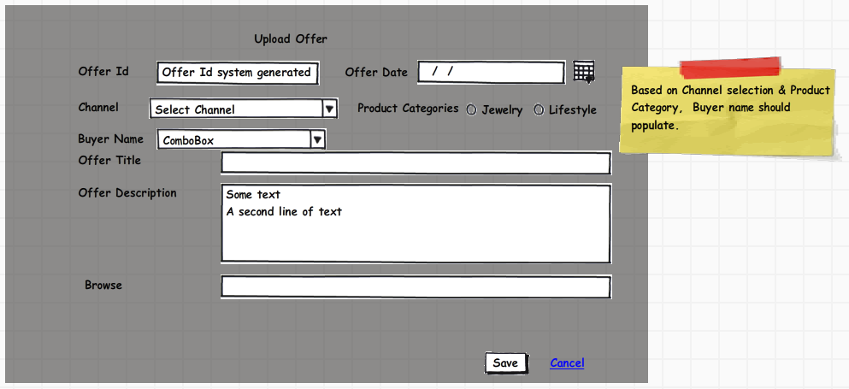

* Offer Id will be system generated. For every new offer uploaded, an Offer Id will be created.
* Offer Id creation is currently manual. So we will use a monthly sequence numbering for the Offer Id.
* For Internal vendors Offer series will be “OI160400001”
* For External vendors Offer series will be “OE160400001”
* **An email will be triggered to respective buyer based on combination of Channel name, Product Category & Buyer name selection**, so that Buyer will be able to know that an offer is uploaded by Vendor.
* Based on Channel & product category selection, Buyer name drop down should be loaded with Buyer name values.
* User should be able to upload the document on the Offer creation screen.
* This offer with the uploaded excel will be visible to Buyer.
* Based on the Channel, Product category and Buyer selected, email will trigger to the respective Buyer along with the respective GMM. (Updated on 26/04/2016)

### Search Offer – Vendor View

Vendor will see the search offer screen like below; Vendor will be able to see his offers only.

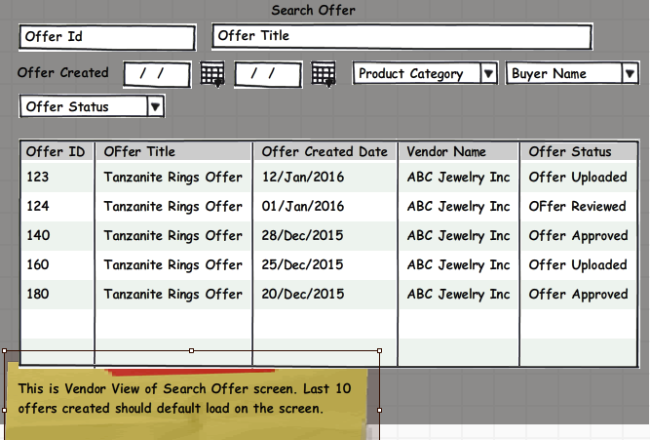

### Offer workflow (Action Taken on Offer)

Offer workflow will have the following status;

1. **Offer Uploaded** (this will be always the first row of workflow, user will not able to choose it from the drop down)
2. **Offer Reviewed**: Based on this status, Buyer will put some comments so that Vendor can revise the offer based on Buyer comments.
3. **Revised Offer**: Based on Buyer comments vendor will upload revised offer for Buyer approval.
4. **Offer approved- send to GMM:** For external vendors, GMM wants to approve the offer, so that there will be control on the purchase from outside vendors. So this status should be visible in case of Outside vendors only.
5. **Offer approved:** This status will trigger the Offer approval email to the required set of people.

Case1: Consider the below scenario;

**Step 1: Vendor Name: Evine Live**. Vendor having user name (TOM) uploaded an offer in the system for Tanzanite Rings. File uploaded was TanzaniteOffer.Xls.

**Step 2: Buyer Name: Manoj Sharma**

Vendor Evine live placed an offer to Manoj Sharma, now Manoj logged into the system. As Evine Live is an external vendor, so Manoj will put his comments and select the status as “Offer approved- send to GMM”.

Offer status: Offer approved- Send to GMM.

**Step 3: Ankur Sogani logged in with GMM role**.

He will see the feedback provided by the buyer and will put his comments for Offer approval. He can also ask for revised offer if he wants.

This way we will use the Offer workflow.

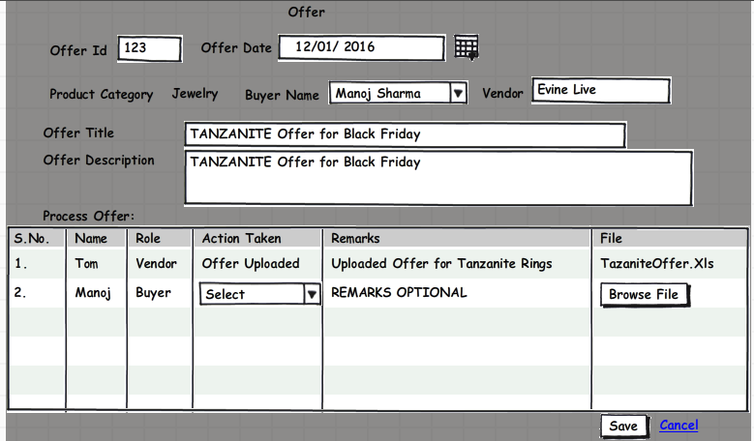

## Shipment Entry Screen

Shipping details entry will be done by Vendor. Once the entry is done and email will be triggered to Buyer about the Shipment done from Vendor side.

Vendor will also be able to upload the excel file about the items shipped.

On save task a shipment tracking number will be generated from the system. This can be used in search.

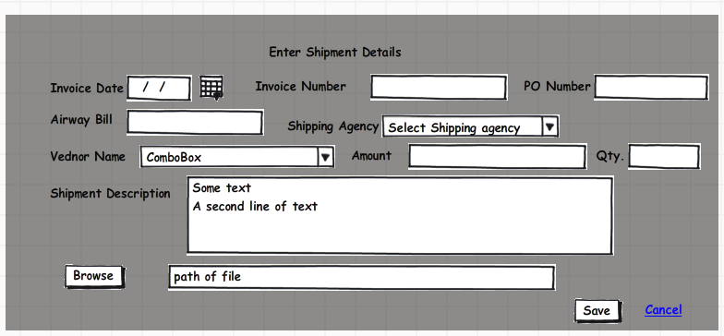

## View Shipment Details entry

In the View mode you will be able to see the details saved in View mode.

# Vendor Order Portal – Buyer View

## Buyer Registration

1. Buyer registration will be done by Super admin from the admin panel. Then login details will be provided to Buyers.
2. If Buyer already has the username and password, he will be able to Sign In by entering correct username and password.



## Buyer Login Details

User name & Password will be provided to Buyer, he will be able to change his password.

#### Login Details screen Acceptance Criteria

* Password requirements will be same like Common Portal for Gemstones project.
* Forgot Password link will open a new window, where user will enter his email id and a temporary password change link will be sent to his email id.
* There should be maximum login attempts defined in the system, to avoid misuse of the Username/Password.
* If user enters the Username and clicks on the login button, then system should give message that "Please enter the password".
* If user enters correct username and wrong password then system should show a message "Please enter correct password" or Click on Forgot Password Link”

## Buyer View -Home Page

Once Buyer will login he will see the home page like below;

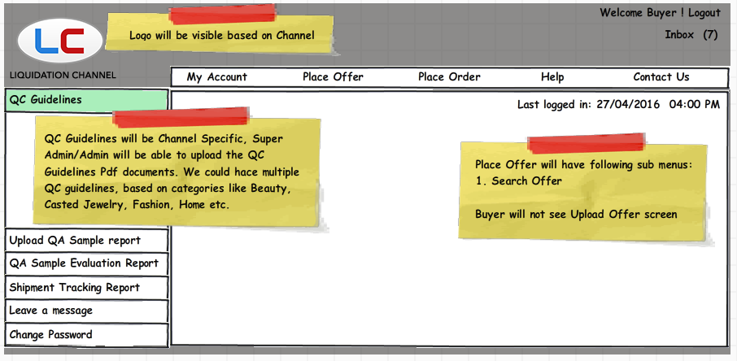

### Home Page screen details

1. My account: This will allow the Buyer to change his Profile details.
2. Shipment tracking report: On this screen Buyer will be able to see the already entered Shipment details entered for earlier shipments in Shipment entry screen.
3. Upload QA sample report: Buyer will be able to upload the QA sample report for the Sample Item codes.
4. QA Sample Evaluation report will be visible to Buyers as well as Vendors. Buyer will be able to see the QA report SKU wise. Buyer or Buyer assistant will be able to upload the QA Sample Evaluation report.
5. Place Order: Once Offer is approved, then user will be able to create Purchase Order based on the approved offer. See the Purchase Order section for Buyer.
6. Logo in the header should be visible based on the Channel Specific.
7. The home page will have Left panel, header portion, Centre display area, Menu bar, logo etc.
8. Leave a message: It will be a chat box where Vendor will be able to leave a message for the Buyer or would be able to see the message left by Buyer for Vendor.
9. Change password: Buyer will be able to change his password.

### My Account (Buyer View)

Buyer should be able to change his email details or his information like Name, Surname, and Designation etc.

### Accounts Details screen Acceptance criteria

* Last update date of “My Account” screen should be available in the right most side of the screen.
* Cancel should ask for the confirmation whether user want to move away from the page.
* Once the details are saved, My account details should be visible in "View" mode. View mode of the screen should show the "Update Account details" hyperlink on it.

## QC Guidelines

QC Guidelines will give information about the QC guideline/requirements for Apparel, Jewelry, Beauty, Home Textile, Home decor etc. This will be defined by Buyer and should be followed by Vendors for the delivery.

Super admin/Admin user should be able to upload the QC guidelines on the portal. These guidelines will be channel specific.



## Place Offer

### Search Offer – Buyer View

Buyer will see the search offer screen like below; Buyer will be able to see offers for his category and Channel only.

Buyer should be able to see 15 Offers by default on page load. These Offers should be based on created date.

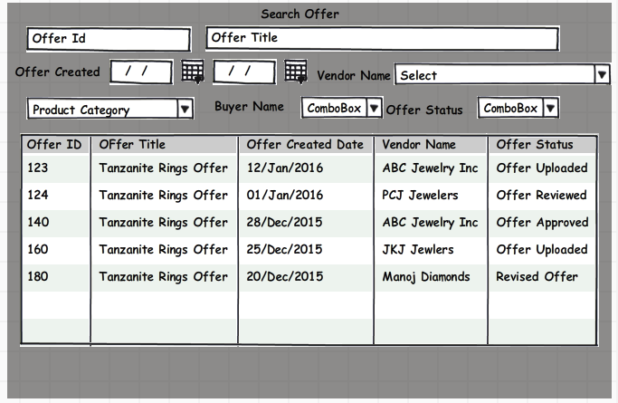

### Offer workflow (Action Taken on Offer)

Offer workflow will have the following status;

1. **Offer Uploaded** (this will be always the first row of workflow, user will not able to choose it from the drop down)
2. **Offer Reviewed**: Based on this status, Buyer will put some comments so that Vendor can revise the offer based on Buyer comments.
3. **Revised Offer**: Based on Buyer comments vendor will upload revised offer for Buyer approval.
4. **Offer approved- send to GMM:** For external vendors, GMM wants to approve the offer, so that there will be control on the purchase from outside vendors. So this status should be visible in case of Outside vendors only.
5. **Offer approved:** This status will trigger the Offer approval email to the required set of people.

Case1: Consider the below scenario;

**Step 1: Vendor Name: Evine Live**. Vendor having user name (TOM) uploaded an offer in the system for Tanzanite Rings. File uploaded was TanzaniteOffer.Xls.

**Step 2: Buyer Name: Manoj Sharma**

Vendor Evine live placed an offer to Manoj Sharma, now Manoj logged into the system. As Evine Live is an external vendor, so Manoj will put his comments and select the status as “Offer approved- send to GMM”.

Offer status: Offer approved- Send to GMM.

**Step 3: Ankur Sogani logged in with GMM role**.

He will see the feedback provided by the buyer and will put his comments for Offer approval. He can also ask for revised offer if he wants.

This way we will use the Offer workflow.

**Updated on 26/04/2016**: Offer approval process will be two step for External Vendors to keep more control over the selection of Offers from External / Outside vendors.

1. First Step approval from Buyer side
2. Second step approval from GMM side (General Merchandise Manager).

For Channels, Internal Vendors are like Vaibhav Global Limited, India; STS Gems Limited, China; STS Gems, Thailand etc.

External vendors will be other than the internal vendors. So in case of External vendors we will show a two-step workflow for Offer approval. Reason to put this 2 step workflow is to have better control over the Offer process with Outside vendors.

### Offer View Mode

Save/Cancel button will be disabled in View mode.

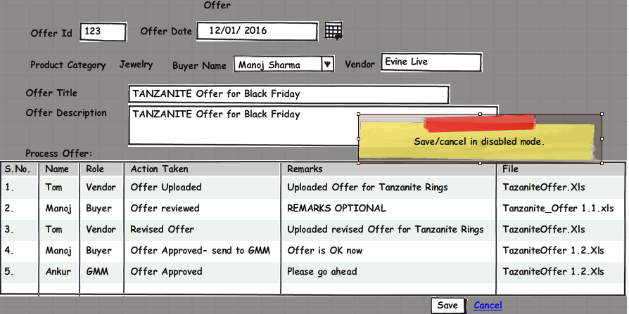

## Place Order- External Vendors

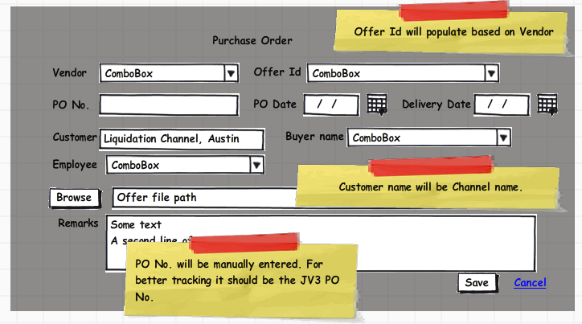

PO Number field should accept alphanumeric and the value entered in the PO number field will be the generated PO number.

While we create the PO in JV3 from approved offer, we will use the Purchase Order number same as our JV3 for better tracking and will upload the offer in the portal.

When Buyer/BPO person/Buyer assitant upload the offer an email will trigger to the vendor, with the PO number, GMM, Buyer selected in the offer.

For Internal vendors we are already using JV3 system for managing POs and end to end tracking for Inventory and payment is available.

## Shipment Tracking Report

User should be able to filter the reports based on Vendor, Airway Bill, Purchase Order Number, Date Range, Invoice No, Invoice Date

|  |  |  |  |  |  |  |  |  |
| --- | --- | --- | --- | --- | --- | --- | --- | --- |
| **Invoice Date** | **Invoice number** | **Airway bill** | **PO No.** | **Shipping agency** | **Purchased from** | **Amount** | **Qty** | **Shipment Description** |
| 5/1/2015 | 105774 | 773509697027 | PO123 | Fedex | KK Jewelry | 1,00000,10 | 1300 | Silver Chains |
|  |  |  |  |  |  |  |  |  |
|  |  |  |  |  |  |  |  |  |

## Vendor Payment Status-PO Wise

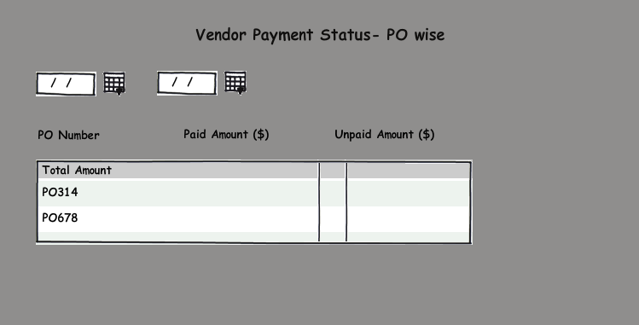

D:\Template\images\1.jpgTotal amount will show the total of Paid amount and Unpaid amount for specific from date and To date

Will revert on this, as this needs to be integrated with JV3

## QA Sample Evaluation Report

Need to take this format from the Business users.

# Super Admin Screens

**Dashboard Menus:**

* Manage Vendors

While managing vendors, we need to note that which Product categories they want to do Business with Channels. Every Vendor should be able to see his offers only.

D:\Template\images\2.jpgFor one Vendor account, there could be multiple Vendors possible.

* Manage Buyers

We should be able to track the Product categories for which Buyer is doing the Business.

* Upload New / Revised QC Guidelines

QC Guidelines will be Channel specific. So US Channel QC Guidelines will be visible to US Vendors only. Same is applicable for UK Vendors also.

* Manage User Accounts

We will track the Vendor and Buyers sessions over the portal.

Vendor and Buyers should be able to see their last login details, once they logged into their user account.

An interface will be provided for Super admin to assign both channels to Vendor – Yes

Super Admin need to add existing Vendor from the backend. The reason is we already have so many vendors available, to which we are doing Business.

**Administer Taxonomy:**

* Define Product Categories – We should be able to add / edit new product categories.
* Define Shipping Option – Shipping option could be FOB, Freight Prepaid etc.
* Type of Organization - Individual, Sole Proprietorship, Partnership, Corporation, LTD, LLP, LLC, Others

**Email Templates:**

1. Registration form Submit : Email to Vendor
2. Registration form Submit: Email to Buyer
3. Vendor Approved: Email to Vendor (with Login details)
4. Vendor Approved: Email to Buyer / Accounts Team (without login details)
5. Offer Uploaded by Vendor: Email to Buyer
6. Offer Status change email to Vendor and Buyer
7. Offer approved by Buyer: Email to Vendor
8. Place Order: Email to Vendor
9. Shipment details entered by Vendor: Email to Buyer
10. Shipment Received by Buyer: Email to Vendor

In future if required there should be possibility to trigger an email to Buyer/GMM for Vendor Profile edit Chandra: 26/04/2016

# Assumptions

1. This portal will be web based application and it will be not be a mobile app.

Q. All BPO users shall be able to see all offers of the channel